Annex-A
“Help Pro Web Application”

Final Year Project Proposal
(BSC/MCS) write only one program
By

S# | Name | Registration #/Roll #/Section | Mobile # | E-Mail
1. | M. Abdul Rehman Faheem | Fa2022-BSCS-225 | 0316-0490174 | abdulrehmanfaheem1@gmail.com
2. | M. Zain Awan | Fa2022-BSCS-226 | 0328-4362008 | zainawan1523@gmail.com

Supervised by:
Mr. Naeem Ahsan ___________________ (Signature)



Department of Computer Science
Lahore Garrison University
Abstract
Natural disasters are inevitable, they come with no pre-call. There’s not any pre-requisite for them, people remain helpless and deprived of many basic necessities of life. Their financial, mental and physical health is affected badly, they have to almost began their life again. Donors find it difficult to deliver aid in the most efficient way.
We have developed the concept of a web application called Help Pro to bridge these barriers between donors and victims. Our web application will act as a bridge for connecting donor and victim with the help of effective communication and assistance between the victim and the giver. Each request from victim and each aid from the donor will be properly verified through a proper and secured process, through the utilization of physical location, real-time updates, and an intuitive user interface. Help Pro aims to enhance coordination between donors and victims, and provide a reliable platform for disaster relief management.

Introduction
Natural disasters don’t usually give a call before coming up, and when they come, there is no time for the people of impacted areas to take safety measures. People become deprived of food, shelter, clothes and other basic necessities of the life. There are people who wants to help the victims, but due to nearly impossible means of communication, they step back. Victims remain deprived of the aid and continue to suffer. There are a lot of remote areas during the natural disasters where physical access is difficult, those areas suffer even more due to lack of communication with the outer world, even the media and governmental organizations find it difficult to reach there. Majority of the victims are unable to communicate their immediate needs, while donors struggle to identify the means of providing help. Help can be in form of shelter, food, medical assistance, clothes and other basic necessities of life.

The real challenge lies in developing such an intermediary system that bridges the barriers between the donor and victim ensuring the aid reaches to those who really deserve it the most. Help Pro is an idea to bridge this gap and addresses this challenge by combining geolocation tracking, interactive maps, and a verification system to facilitate real-time disaster relief, reduce response time, and enhance coordination between donors and victims.

By integrating our idea with the technology – we will build an innovative and user-friendly application, Help Pro aims to connect volunteers, victims and donors in such a way that minimize the response time and ensures efficient aid allocation, with accountability and proper verification, and which results in enhancing the overall workflow, efficiency, and impact of disaster relief operations on the people of affected areas.

Problem statement
Help Pro a web based platform that connects victim and donor in real-time. Victims can post for their needs, and the volunteer can locate the nearby victim and provide help. During the natural disasters, the affected comminutes have to relocate themselves to a safe place which results in loss of livelihood and shelter, and the victims have to suffer and struggle even to get basic necessities of life. Volunteers also struggle to get to victims to provide them with help. There is no centralized system to manage this gap between volunteers and victims of a disaster. Help Pro aims to solve remove this barrier by integrating geographical locations, interactive maps and a verification system to ensure reliability and authentication.

Literature review
1) Disaster Management Apps (e.g Google Crisis Map, Relief Web, Sahana Eden):
- These existing platforms provide information about the areas affected by natural disasters.
- They help governmental organizations to initiate relief operations by providing them location and data providing services.
2) Ushahidi & Aid Matrix:
- Aid Matrix is a non-profit organization which focuses on aid logistics to the people in need.
- Ushahidi is a platform for crowd-sourcing during a natural disaster to locate where there are affected people on map.
- Offer services for the collection of data and locating the affected areas.
3) Social Media-based Assistance:
- Social media (whatsapp, Facebook, twitter) is also a powerful platform during the natural disasters for spreading information about the affected areas.
- Donors and volunteers take actions based on the information provided by social media platforms.
4) Disaster Alert Systems (e.g., FEMA App, Earthquake Network):
• These platforms provide live information about the affected areas due to natural disasters.
• They also notifies people about the alarming situations or the highlights the areas which can be affected by disasters in near future.
Gaps Identified:
After analyzing existing solutions in disaster relief and aid distribution, the most significant gap is the lack of real-time interactivity and direct, one-to-one communication between volunteers or donors and victims. All these organizations and platforms assist in locating the people in affected areas during such natural disasters but fails to provide direct services for connecting the donors and victims one-to-one. There lies a gap of providing the aid physically to the needy. The consequences of these gap are quite crucial and they can not be avoided or ignored, they often results in delays, miscommunication, and reduced effectiveness of aid delivery. With all these short- comings and identified spaces, there is a need for a system like Help Pro which will focus on a providing aid to right person efficiently.

Project scope
Help Pro is a web-based platform designed to connect disaster victims with donors in real time. During the hard times of natural disasters, the affected people who need help face difficulties while communicating their needs to world. On the other hand, the donors can not find an authentic way to communicate with the victims. This project focuses on providing an efficient, reliable, and transparent system where victims can request aid, admins can approve requests, and donors asses the requests on map and provide help if feasible.

Objective:
Reduce the communication gap between victims and donors.
- User-friendly and user-interactive maps.
- Focuses on communicating the aid to the righteous person.
- To provide users with easy and simple to use system.

System Workflow
- Victim Request: Victims will post an update demanding the aid, this update will carry all the information about the aid requested (location, type, description and other details).
- Admin Verification: Admins will verify the victim’s update to ensure it’s authenticity.
- Donor Access: Once the requests are verified, they are posted on the UI from where donors view the requests.
- Direct Coordination: Donors can directly contact the victim to provide aid.
- Confirmation: After donor has provided the victim with aid, the admin verifies the completeness from both ends.
- Dispute Resolution: In case of any dispute or partial completeness, the request stays in disputed status.

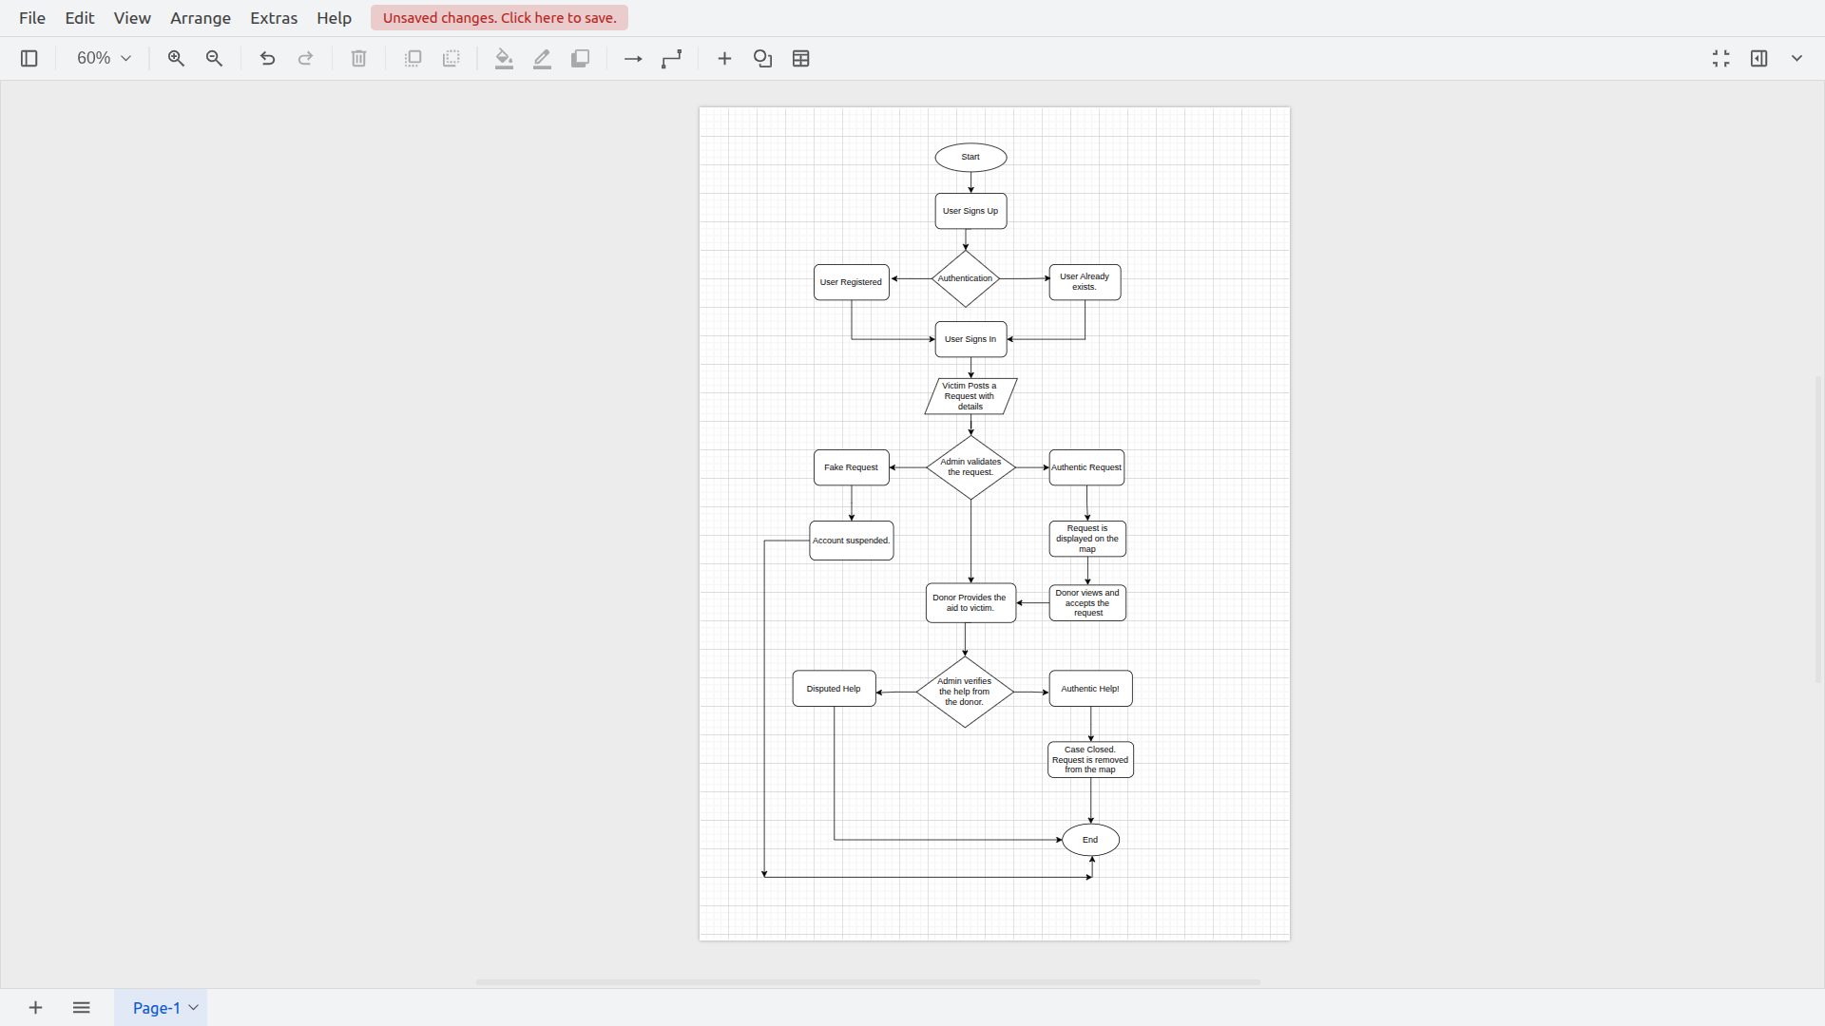
Limitations:
Internet Dependency:
- Help Pro needs internet for it’s working and It can not be used offline.
Accuracy of User Location:
- Location data depends upon live location of the registered user.
- Errors or differences in location might cause disputes in providing aid.
Verification Delays:
- Request verification is necessary, admin will approve the requests of victims, which sometimes will delays the help.

Project development methodology
To ensure methodical planning, development, testing, and deployment, Help Pro, a web-based disaster relief platform that connects sufferers and donors, will be developed using an organized and iterative methodology.

1) Front-end:
- React JS – A JS library which allows modularity to make responsive and interactive web pages.
- Leaflet JS – A JS library used for interacting with the map.
- OpenStreetMap (OSM) API: An open-source API to use maps in a web application.
- Bootstrap – For styling, layout, and responsiveness.
2) Back-end:
- Node JS & Express JS– JavaScript’s backend framework for developing RESTful APIs.
- MongoDB – It serves as the database for the user data with express JS in Node JS.
3) Tools:
- VS Code – Source code editor.
- Postman – For testing APIs.
- Git & GitHub – Version control platform which allows collaboration with other developers.

4) Technologies:
- HTML & CSS – For structuring and styling web pages (UI).

Project milestones and deliverables
Project Milestones:
- Requirement Gathering – All the aspects of the project are deeply researched and relevant information is gathered through existing platforms.
- Frontend Development – It includes User Interface (UI), structuring and styling the web pages.
- Backend Development – It involves developing REST APIs and integrating them with frontend, along with the business logic.
- Integration & Testing – Integrating frontend with backend and focus on proper testing to ensure smooth workflow of system and a good user experience.
- Final Deployment – The web application will be hosted on a cloud platform for users to use it.

Deliverables:
- Functional Web Application: HelpPro is a fully functional web-based platform that lets disaster victims post requests for help, and enables donors to quickly find and provide support in real time.
- GitHub Repository of the production: A properly maintained GitHub repository with the source code, commits history, database schema and scripts.
- Project Documentation: Project documentation will cover all the literature part about the implementations from abstract, introduction, methodology, system design, testing procedures, user manual, to deployment steps providing a view of system’s development and deployment.
- Deployment of Application: The application will be deployed on a cloud platform, it will enable live demonstration, real-time testing, and easy accessibility for the users.

References
- Yuan, F., et al. (2021). Smart Flood Resilience: Community-scale Big Data for Flood Impact Assessment. Retrieved from https://arxiv.org/abs/2111.06461

- Abbasi, S., et al. (2022). Trustable Mobile Crowdsourcing for Information from Flooded Areas. Retrieved from https://arxiv.org/abs/2203.07028

- Lorini, V., et al. (2019). Integrating Social Media into a Flood Awareness System. Retrieved from https://arxiv.org/abs/1904.10876

